# Conflict Scenario

## **Review**

### Interpersonal Conflict Management Styles

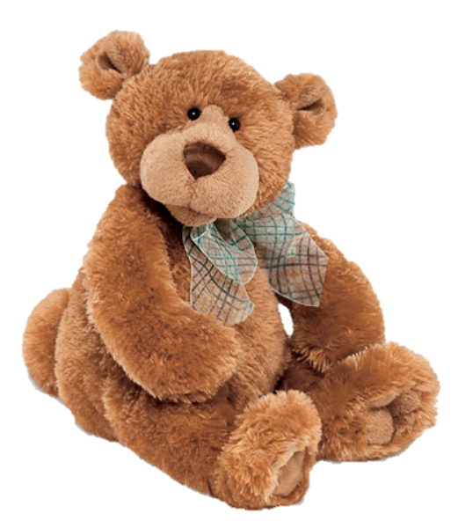

[CC 2.0 BY Matthew](https://www.flickr.com/photos/falcon1961/3304306800/)



[CC SA 3.0 Unported BY Jonathan Zander](https://en.wikipedia.org/wiki/File:Florida_Box_Turtle_Digon3.jpg)



[CC 3.0 BY Superawesomevectors](https://superawesomevectors.deviantart.com/art/Shark-Cartoon-Free-Vector-Illustration-643399222)



[CC0](https://pixabay.com/en/urban-lost-hiding-afraid-1002149/)

Low to High Concern for Other

Concern for Self

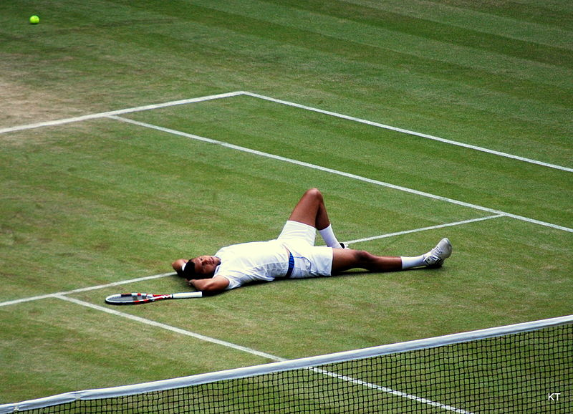

CC SA 2.0 Generic BY [Carine06 from UK](https://commons.wikimedia.org/wiki/File:Flickr_-_Carine06_-_%22I_give_up.%22.jpg)



CC 2.0 BY [Zabara Alexander](https://www.flickr.com/photos/zabara_tango/6955720271)

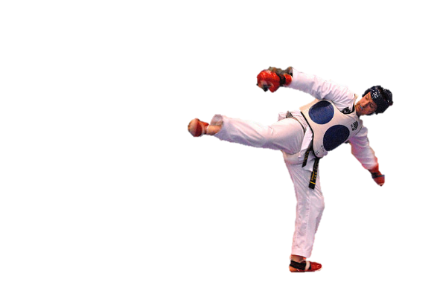

[CC0](https://commons.wikimedia.org/wiki/File:US_Army_53525_Soldiers_compete_in_Tae_Kwon_Do_tournament_for_Warrior_Country_level.jpg)

### **Interpersonal Conflict Resolution**

The following diagram shows a process that can be followed when trying to resolve interpersonal conflict.

### Listening

A considerable proportion of our communication involves listening, yet little attention is devoted to improving listening. HURIER is an acronym for tips that can be used to improve listening.

### “I” Phrases for Conflict Resolution

The “I” phrase is used during conflict resolutions to avoid attacking others. Open the conversation with a statement in first person, passive voice: “I feel … when … because … I would like …”

Adapted from (Dwyer 2012, p. 40)

## **Student Name and ID:** Clare Alexander 12190615

## **Student Name and ID:** Click or tap here to enter text.

## **Scenario**

Find a partner. Read the scenario below. Choose one partner to be Joe Bloggs, and the other to be Jane Doe. Together, answer the following to help prepare you for the role play.

## **Scenario: Joe did not complete a task by the deadline**

Joe and Jane are working on a report that is due today. Joe was assigned the task of writing the executive summary. Unfortunately, Joe has not completed the task.

What is the most appropriate conflict management strategy for Jane to use in this situation? (Choose one)

Compete/Force

Compromise

Avoid/Withdraw

Collaborate/Confront

Accommodate/Smooth

Why did you choose the above conflict management strategy?

By collaborating Joe and Jane will be able to come up with a solution to the original problem. If one party confronts the other on the issue it can lead to collaboration and understand-ment between both Joe and Jane.

### **Listen and Understand**

How could Jane start the conversation?

‘Hey Joe, I was wondering if you had your part of the work finished?’

Describe the purpose of the discussion. Describe the conflict. What questions could Jane ask to determine Joe’s perspective of the situation?

The purpose of the discussion is for Jane to find out why Joe has not completed his part of the work they had. The conflict is from Joe being unable to complete his work which effects Janes work as well. Some questions Jane could ask are: ‘was there a reason that you couldn’t complete the work?’, ‘Do you need help completing this?’, ‘have you not started your section of work at all, or do you have something?’

Write sentences that features the “I” phrase, such as in the example below:

“I feel *[your feeling]* when *[their behaviour]* because *[effects on you]*. I would like *[alternative behaviour]*”.

I feel annoyed that you have not completed your task.

Invent a reason why Joe did not complete the executive summary by the deadline.

I’m sorry but unfortunately, I’m unable to finish the task because my computer was not operating properly.

How could Jane paraphrase Joe’s reason for missing the deadline to ensure that she understands Joe’s perspective?

Your computer wasn’t working? Why didn’t you tell me earlier?

### **Empathise**

Now that Jane understands Joe’s perspective, how could Jane empathise with Joe? Write a response that shows that Jane identifies with Joe’s emotions.

I know it’s hard to complete things without a laptop.

### **Apologise**

Include an apology if it is appropriate.

I’m sorry.

### **Offer Solution**

What question could Jane ask to help build Joe’s involvement with potential solutions?

You can use my laptop if you want and finish your work.

Come up with a way for Jane and Joe to settle on a solution.

### **Resolution**

How could Jane resolve the conflict? Jane needs to ensure that Joe agrees. Write a response that outlines appreciation for the solution.

Please take my laptop and we can work together to finish the task.

### **Reconciliation**

How could Joe reconcile the relationship and let Jane know that she is important to him?

Thank you for offering me your laptop. I’ll finish my work now. Once again Thank you so much.

How can Jane let Joe know she is listening while Joe is talking?

Jane can maintain eye contact with Joe, repeat information back to him and ask questions related to the topic.

What could Jane do if Joe started to withdraw from the conflict at any stage?

Depending on how Joe is withdrawing from the conflict Jane may do a few different things i.e. If Joe is withdrawing by shutting down, then Jane may have to change the way she is speaking to him or step back from the conversation to calm down.